Logo Development:

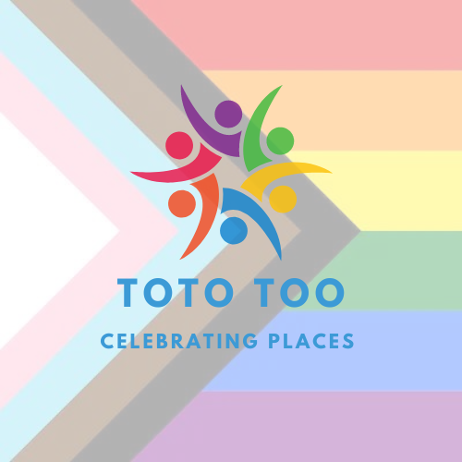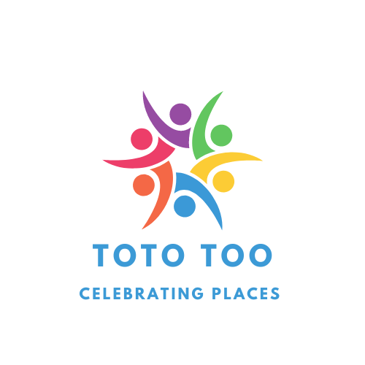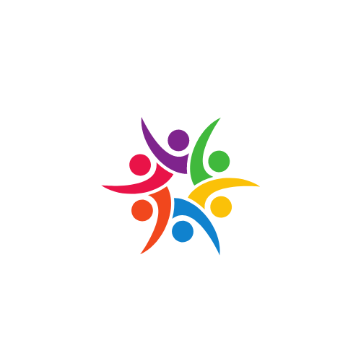

The centre of the logo is a circle of 6 people, in different colours of the rainbow, which is included in the logo due to it's relation with the LGBTQ+ flag. The colours are indicative of who our brand is for.

Red: Life

Purple: Intersex

Green: Prosperity

Yellow: New Ideas

Blue: Serenity

Orange: Healing

We've used 'Celebrating Places' as the charity's slogan because it reinforces the underlying premise of our project that we find and share places that celebrate safety, unity and inclusivity.

This is the final logo we have created for the charity, using the progress pride flag in order to reinforce that our charity is for all LGBTQ+ youth and marginalised communities.